QEMU Manager Pro Documentation

Project Overview
QEMU Manager Pro is a graphical user interface (GUI) built using Python's tkinter library that provides a simplified interface to manage virtual machines using QEMU. This application enables users to create, edit, launch, and manage VMs using intuitive controls, color-coded actions, and persistent project configuration.

Features

1. Create Virtual Disk
- Create new virtual disk images in formats: qcow2, raw, vhdx, vmdk, vdi
- User specifies:
  - Disk name
  - Size (e.g., 20G, 100M)
  - Format
  - Save location (using a file browser dialog)
- Disk is created using qemu-img and saved to the selected directory

2. Edit Virtual Disk
- Load and inspect existing virtual disks
- Resize disk (only supported for formats like .qcow2 and .raw)
- Convert disk between supported formats
- View detailed disk information using qemu-img info

3. Launch Virtual Machine
- Load existing virtual disk and ISO image
- User selects:
  - Virtual Disk using a file browser dialog
  - ISO Installer using a file browser dialog
  - RAM (in MB)
  - Number of CPU cores
- Confirm settings in a summary dialog
- VM is launched using QEMU, with ISO mounted as CD-ROM (-cdrom) and disk as hard drive (-hda)
- Boot order is set to CD-ROM first (-boot d)
- Project is saved automatically as a JSON configuration for future reuse

4. Manage Virtual Machines
- List all saved VM project configurations
- Start or delete saved VM projects with one click

Dependencies
- Python 3.6+
- QEMU binaries installed (Paths must be set to qemu-img.exe and qemu-system-x86_64.exe)
- tkinter (standard with Python)
- Windows OS (tested)

Configuration

Required Paths
Modify the following variables in the source:
QEMU_IMG_PATH = "C:/msys64/ucrt64/bin/qemu-img.exe"
QEMU_SYSTEM_PATH = "C:/msys64/ucrt64/bin/qemu-system-x86_64.exe"
VM_PROJECTS_DIR = "D:/VMs/projects/"
Ensure QEMU is installed in the specified location or adjust accordingly.

Technical Breakdown

GUI Framework
- Built with tkinter
- Custom color theme defined in a COLORS dictionary
- Modular sections:
  - Sidebar Navigation
  - Pages (Create, Edit, Launch, Manage)

Disk Management Logic
- qemu-img is invoked via subprocess.run() for disk operations
- Supports disk size validation and suffix checking (G, M, K)
- Displays output or errors using messagebox

VM Launching
- Uses subprocess.Popen() to non-blocking start QEMU VMs
- JSON config files are created in the projects directory
- ISO and Disk are mounted with -cdrom and -hda respectively
- Boot order set to CD-ROM (-boot d)

Error Handling
- Field validation for disk creation and VM launch
- Format validation for disk size and file extensions
- Graceful failure handling with user feedback dialogs
- Warning users of unsupported formats for resizing

Screenshots
See screenshots directory for GUI walkthrough:
- Create Disk Page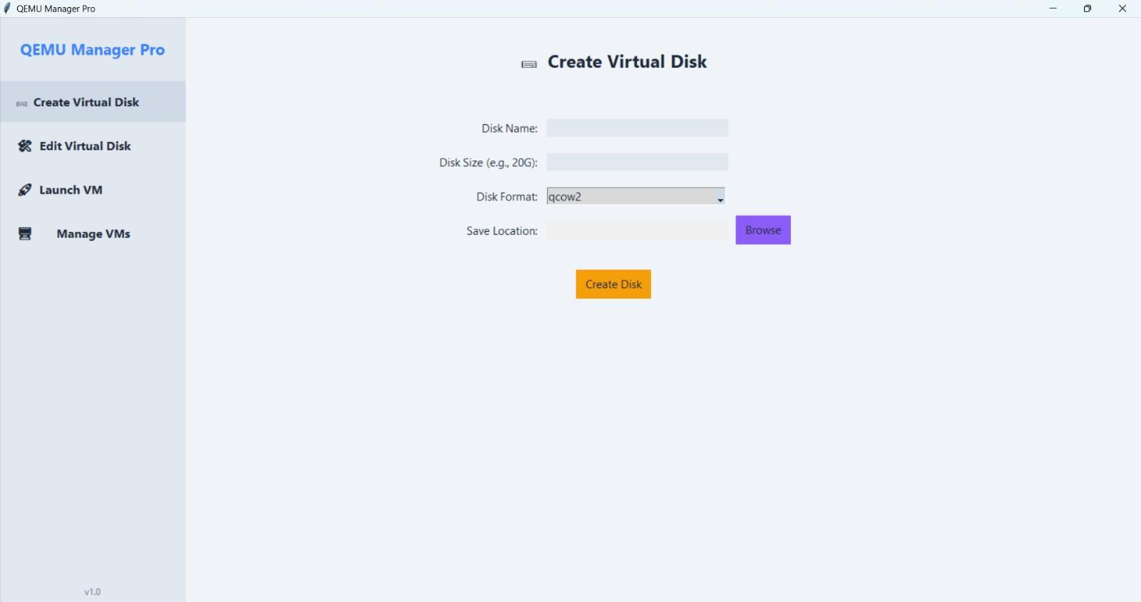

- Edit Disk Page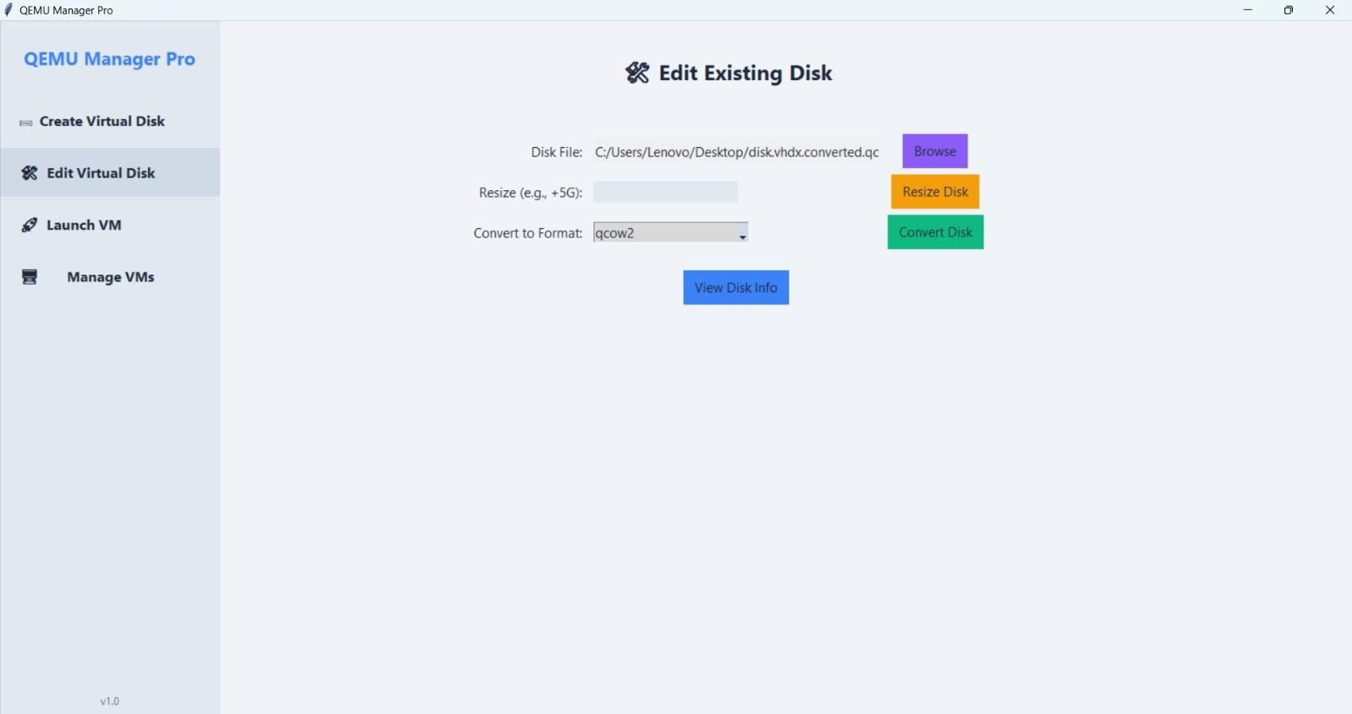

- Launch VM Page
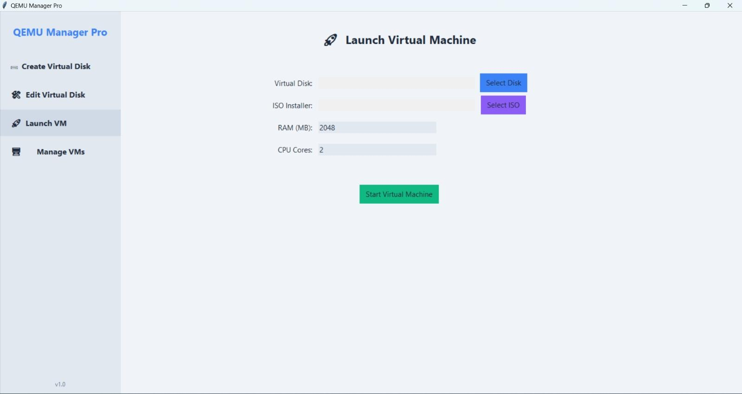

- Manage VMs Page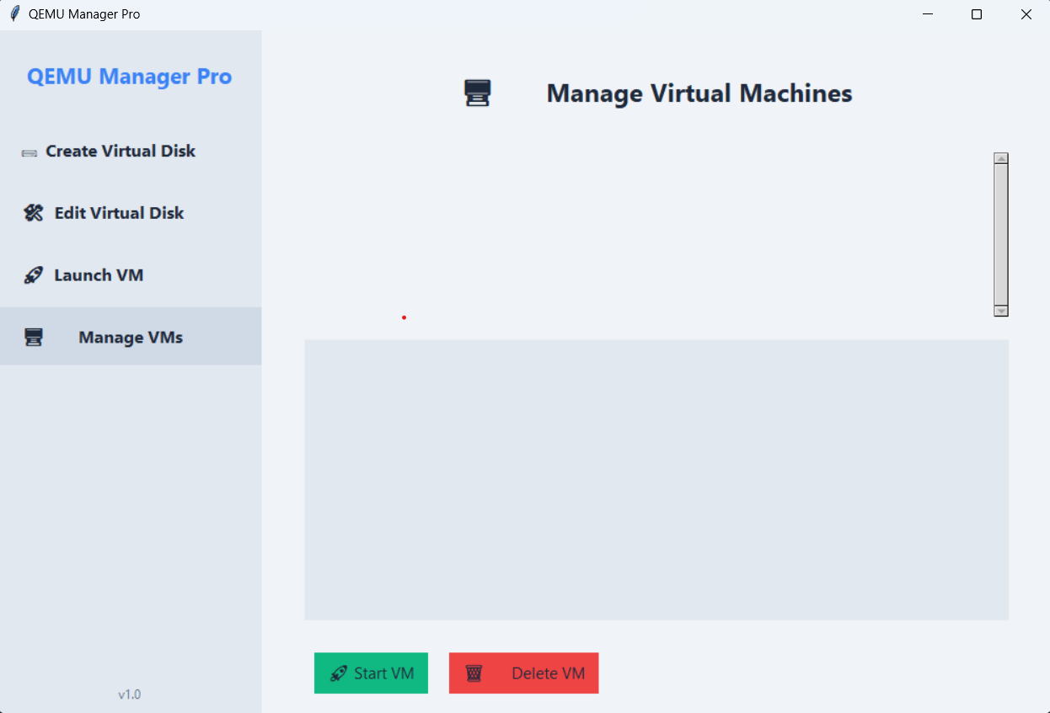

Developed By:

- Rawan Walid 223177
- Noha Ezzat 221489
- Rokaia Emad 220617
- Nadeen Amir 222195
- Salma Ehab 238787

